# Virtual Nanny Development:

## How to navigate through this guide:

Press ctrl + f and navigate through the headings. I have sorted them by topic and documented each step from start to finish. ☺

## Creating the project:

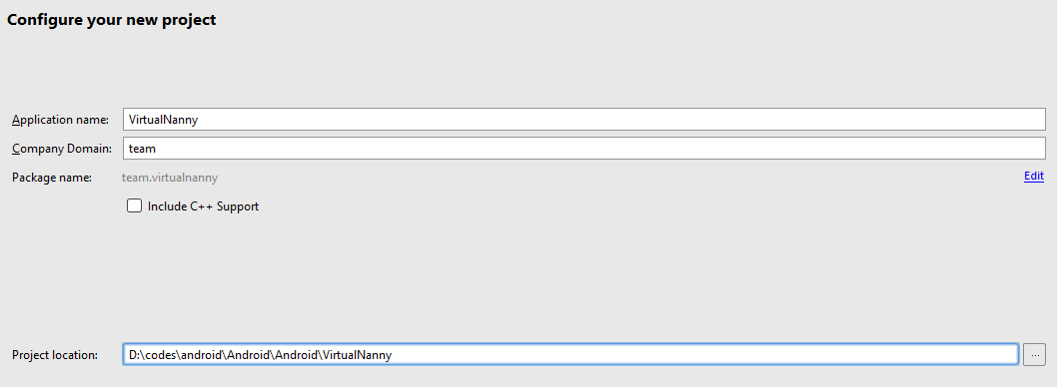

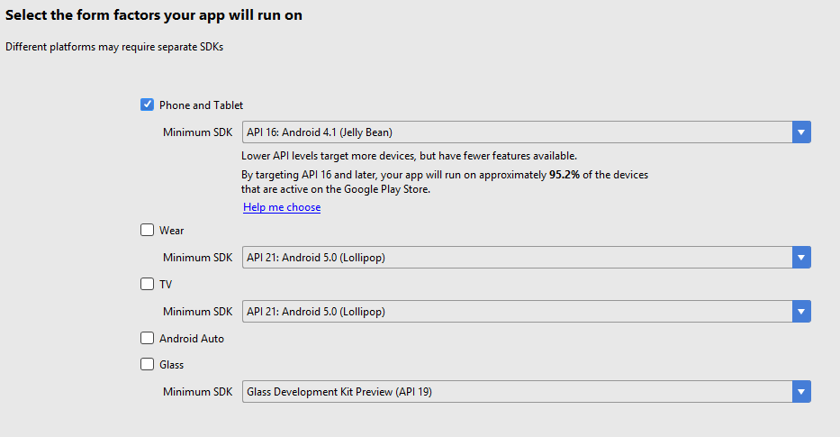

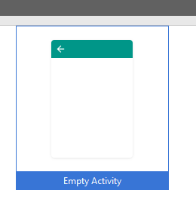

## Debugging the project

### Using phone:

Like in eclipse, android studio also gives you the feature to use your phone to debug. To allow usb debugging, turn on developer mode on your device and connect your phone to your computer then click on the “run” button and check if your phone is detected. You should be able to see the following screenshot.

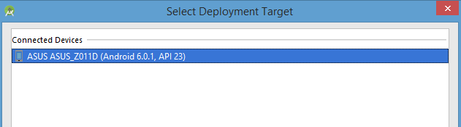

If it is not detected, please check if the proper drivers are installed on your phone.

Links:

<https://www.kingoapp.com/root-tutorials/how-to-enable-usb-debugging-mode-on-android.htm>

### Using a virtual Device:

If for some reason you do not have an android device, android studio also has an option where you could create a virtual android device (an android on your computer). This is mainly used for testing multiple versions of a device since you can specify the version and size of your virtual device. It’s cheap but slow when building.

### Project Directory:

The following is the directory of a newly created android project.

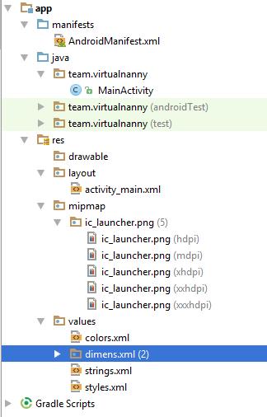

Since we are just starting, I would like to focus on the following 3 files:

AndroidManifest.xml – This is where all activity names are placed. This file determines what activity will be run first. What actions android does are based on the activities that are run.

MainActivity.java – Found in the java folder. This is the default activity that will be run by the project. You can also put the button functions and other functionalities of your project.

activity_main.xml – Found in the layout folder. This file determines what the page will look like, what is should do, etc. This is called by MainActivity.java.

These are the basics on what is needed for a simple android project to run.

<https://developer.android.com/studio/projects/index.html>

<http://www.compiletimeerror.com/2013/01/directorystructure-of-android-project.html#.WHPF8FV97IU>

### Enabling firebase:

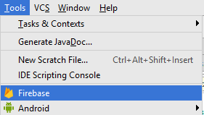

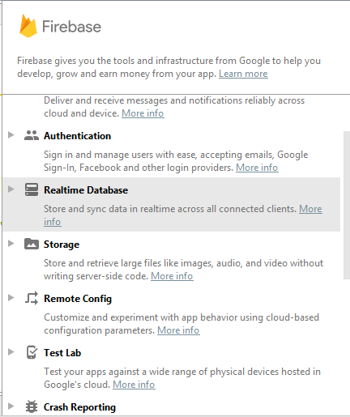

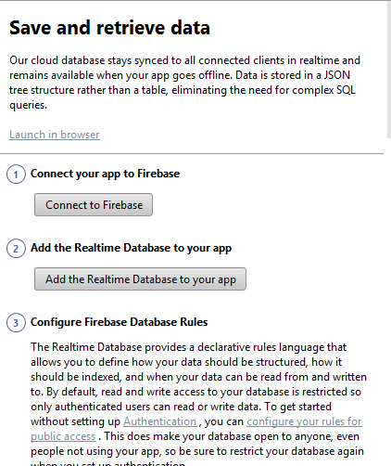

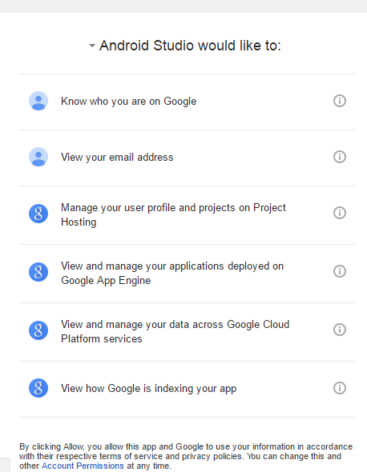

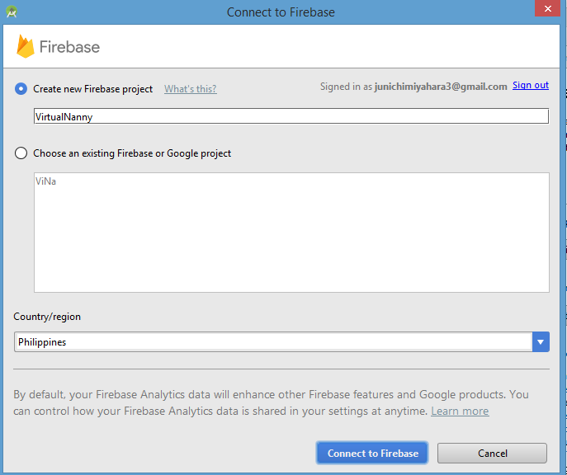

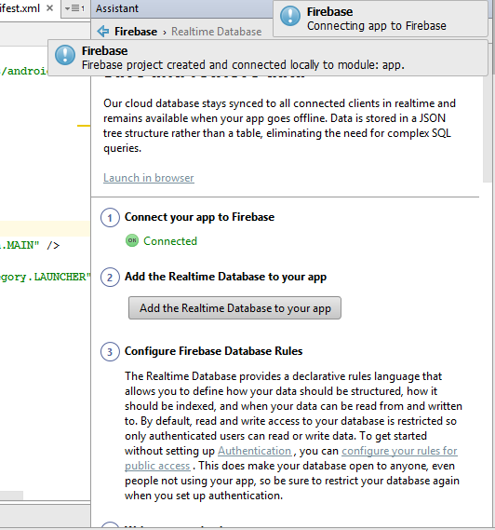

<https://firebase.google.com/docs/database/security/quickstart?utm_source=studio#sample-rules>

## To install:

### Drawable Importer:

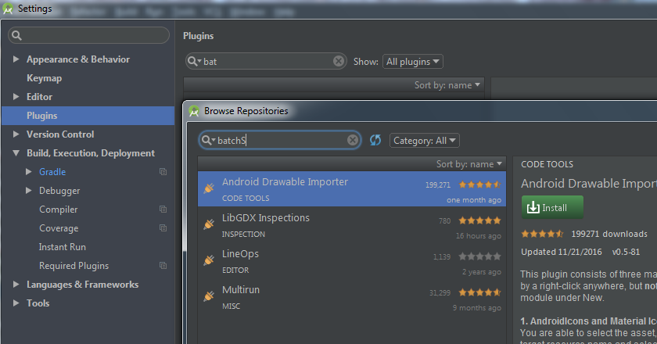

### Google Play Services:

